**Recording Font Color Changes in Word 2010 Macros:**

The 2010 version does not appear to support color changes from the top menu :

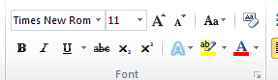

So, we found a work around. While recording a macros, select font color by clicking the arrow in the Font menu corner:

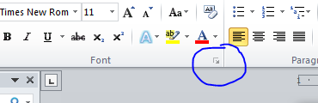

This will bring you to the font dialogue box, where you can select the color (among other things). Make sure to click okay.

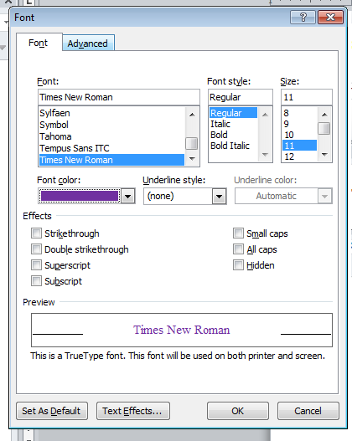

Then, you can continue recording as normal, or stop the recording. This will properly save your color selection in the macros. Everything else should work as normal.